

Capstone project phase A

EasyFit

project number. **23-1-D-18**

Supervisor: Zeev Barzily

|  |  |  |
| --- | --- | --- |
| **Name** | **ID** | **Email** |
| Din Salman | 204404024 | Din.Salman@e.braude.ac.il |
| Eran Jehassy | 203506597 | Eran.jehassy@e.braude.ac.il |

**Contents**

Figures………………………………………………………………………………………………….3

Abstract………………………………………………………………………………………………….3

1. Introduction 3

1.1 Stakeholders: 4

1.2 Document Review: 4

2. Background and related work: 4

2.1 Fitness products: 4

3. Expected Achievements 5

3.1 Personalization: 5

3.2 Autonomy: 5

3.3 Feedback: 5

4. Research / Engineering Process 6

4.1 Process 6

4.1.1 The engineering research and development process 6

4.1.2 Challenges 6

4.1.3 Software development methodology 6

4.2 Product 7

4.2.1 Software Architecture 7

4.2.2 Use Case Diagram 7

4.2.3 Class Diagram 8

4.2.4 Activity Diagram 9

4.2.5 User Interface 10

5. Evaluation \ Verification Plan 13

5.1 System Requirements 13

5.2 Testing Plan 13

6. References 18

# 

# Figures

Figure 1 – System Architecture 7

Figure 2 – Use Case Diagram 10

Figure 3 – Class Diagram 12

Figure 4 – Activity Diagram (Registration) 12

Figure 5 - Activity Diagram (Request Exercise Change) 12

**Abstract**

The growing prevalence of seated and physically inactive lifestyles across the world has had negative health consequences. Despite the importance of regular physical exercise, many people can’t find the motivation to do so. Advances in technology create opportunities for solutions to promote long-term fitness. Personal training has been shown to be an effective strategy to change attitudes and increase physical exercise. Studies have also highlighted the need for personalized workouts and goals in fitness apps, as current applications often don't take into account individual factors like fitness level, medical conditions and more. The "one size fits all" approach common in most fitness applications also hinders motivation and autonomy, leading to reduced use and abandonment of exercise. The proposed project aims to create a system that solves said problems by pairing the client with a personal trainer who will provide personalized, encouraging and accountable workouts to help clients achieve their goals and maintain long-term consistency.

**1.Introduction**

Because people are becoming more sedentary, there has been an increase in physical inactivity on a global scale. Despite the phenomenon's negative effects, many people struggle to find the motivation to engage in physical activity.  
Technology advancements offer possibilities for widespread treatments to promote long lasting physical exercise, though.  
  
The evidence indicates that one-on-one personal training is a successful strategy for modifying attitudes and consequently increasing physical activity [1].  
However, many people are put off from hiring personal trainers for a variety of reasons, including shyness, cost, proximity to the trainer, and more.

Furthermore, studies show that it is vital in fitness apps to have personalized workouts and goals [2] – unlike today’s most applications that usually have premade workout plans that do not take into consideration many factors such as: current trainee fitness level and strength, medical issues and more.

Lastly, the “one size fits all” approach, which is prevalent in most fitness apps, like 10,000 daily steps for everyone [3] - hinders motivation and sense of autonomy and makes people stop using the apps and quit exercising completely.

The project's objective is to create a system that enables customers to have a personal trainer online, and to make sure that the clients remain consistent for a long time to achieve their goals, and not quit.

The system will pair clients with personal trainers to be held accountable to.

The trainers will encourage the clients, build personalized workouts and view weekly reports to make sure progress is made.

**1.1 The system stakeholders**

* private users: everyday users who want to work out with a personal trainer, but not necessarily have him around during sessions.
* Personal trainers: professionals who want to have a side income, because the system allows for remote training, without physically being near the trainee, freeing up time for the trainer.
* Gyms: gyms that want to incorporate the system with their own personal trainers to encourage new costumers to the gym.

**1.2 Document review**

At the beginning of the book, we present the background for choosing the project / the problem. Then, the primary solutions that have already been developed in the Personal Training Field. Next, we will present the principles of the system and how we will implement them. The book's central chapter details the engineering process we had, the challenges we will have, and the available solutions for the development process. Later, we will present system structure, logic, and interfaces using diagrams. Finally, we will detail the system's requirements, and present a detailed testing plan

**2.Background and related work**

**2.1 fitness products**

* **Nike Training:** the Nike app have premade workouts and programs the trainee can choose from. Trainee can choose 3 levels of intensity and fitness, duration time or workout focus (strength, mobility, endurance, yoga).

Has a long list of workouts, but are not tailored to specific people. Just fitness levels. No further personalization is present.

* **JEFIT**: just like the Nike app, has premade workouts. Contain even less personalization. Can choose workout based on muscle group or from a list.
* **Wellix**: a personal trainer software that allows clients to schedule appointments.

This software is about booking workouts and managing payments. It does not let trainers send the workouts to clients. This means the clients have to reach the trainer. They are not able to work out by themselves.

* **Classical personal trainer:** in the classic meaning, a client will go and meet the personal trainer in the local / trainer’s gym and be supervised during the session.

This method requires proximity to the trainer and allocating time that is accepted by both parties. Moreover, some clients might not like the trainer to hover over them and would like to do the actual training alone.

**3. Expected Achievements**

Based on the problem we presented and the existing solutions, we wanted to find a solution to encourage exercise and consistency, taking into account several principles:

1. **Personalization**: from our research this is the most important concept to implement in order to make clients achieve their goals and work out for a long period of time.
2. **Autonomy**: Allow the user to feel like they are part of the process, to make changes according to his preferences and needs. Give them a sense of control over the process.
3. **Feedback**: Provide feedback to the trainee, that includes possible mistakes and problems with their workout, or giving encouragement for good work.

**3.1 Personalization:** The ability of the trainer to give the client a personalized workout based on the client’s needs, target and limitations. A trainee can have different targets, preferred exercises, availability issues and more. Even more important, a trainee can have different medical issues requiring specialized exercises. Therefore, the system will use real people (personal trainers) to achieve maximum compatibility between trainee and training program, as we think an algorithm will be insufficient to accommodate many needs (medical and otherwise).

* **View trainee information**: the trainer must have the ability to view the trainee’s personal information including medical issues, available time per week for training, targets and any relevant information to customize the training to the trainee.

**3.2 Autonomy:** The trainee should have some control over his training even though the professional authority is the trainer. Therefore, the system will have the following guidelines:

* **Change Exercise**: the trainee can request to change an exercise for any reason. Whether he has problems the trainer cannot fix, or simply personal preferences.
* **Change target**: the trainee can change the training target anytime. From losing fat to bulking or general health, the target is defined by the trainee.
* **Change trainer**: the trainee can request to be assigned to a different anytime for any reason: be it personal dissatisfaction, no connection and more.

**3.3 Feedback:** For the trainee to improve, it is important to allow him to get feedback from the trainer about his progress and his workouts after he submits his weekly report.

The feedback contains information about progress made, suggestions for the future and answering questions and problems the trainee faced and reported.

* **Errors**: the trainee did not follow instructions correctly, did not work out the required number of times during the week, did not achieve any personal missions.
* **Satisfactory**: the trainee worked out the required amount, performed the exercises as written, managed to do the required sets and repetitions.

1. **Research / Engineering Process**
   1. **Process**
      1. **The engineering research and development process**

* Preformed research in fitness fields regarding personal trainers, their contribution and maintaining consistency among trainees for long periods of time.
* Performed research regarding competitors and similar products in the market, and analyzing their pros and cons to better our product.
* writing out the specific system requirements for the system and developing a testing plan to match them.
* Deciding on a development model.
* Deciding what tools and technologies to use to implements said system.
* Designing system diagrams, UML and architecture.
  + 1. **Challenges**
* **Exercise presentation:** each exercise in the system should be displayed to the trainee in an adequate manner because the trainer will not be present with him.

Therefore, the system will display high resolution images / animations of the exercises and will link to YouTube videos that are made by the staff for further explanation if needed.

* **Security**: The system saves some sensitive information – like medical issues. Security measures should be placed to make sure privacy is maintained.
* **User experience**: Trainees already have a hard time having consistency with training. Therefore it is necessary to make sure the User Experience is smooth and frictionless.
  + 1. **Software development methodology**

After researching some software development methodologies [4], we have decided on the “Waterfall” approach because of the following reasons:

* Project size and timeframe: because it is not a very large project, and we have only a limited timeframe the project will require less adjustments and would benefit from a more linear model.
* Flexibility: because of the limited timeframe, we are limited in our flexibility to change requirements and we would benefit greatly from predictability.
* The project is well defined, with requirements and a testing plan in place.
  1. **Product**
     1. **Software Architecture**

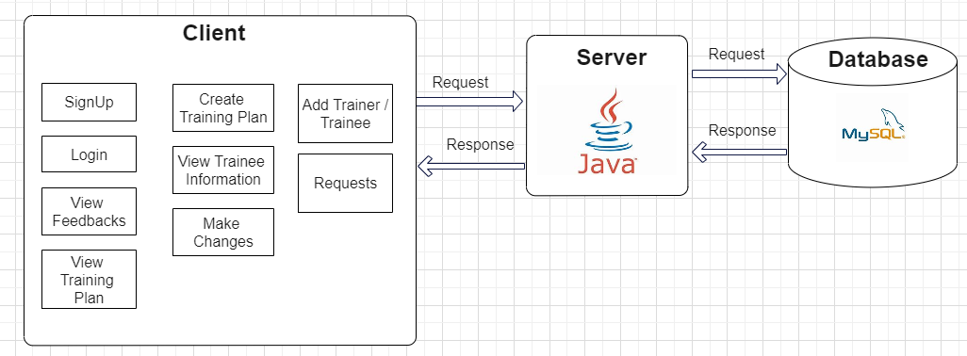

**4.2.2 Use Case Diagram**

The Use Case Diagram is used to model the functional requirements of a system, by showing the actions that actors (users) can perform in the system.

The following diagram shows describes the actions that the actors “Client”, “Trainer”, “Manager” can perform in our system.

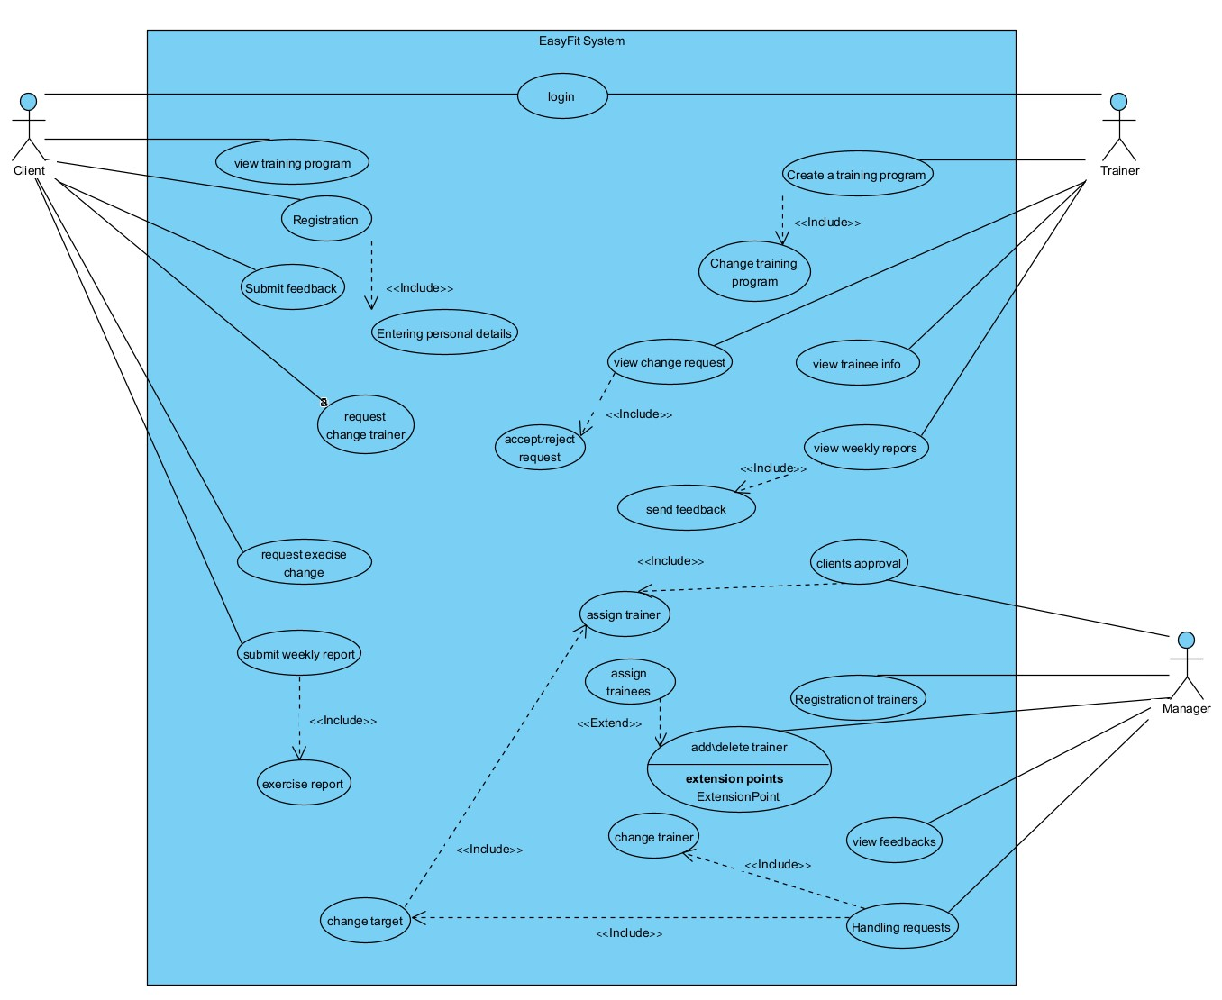

Figure 2 - Use Case Diagram

**4.2.3 Class Diagram**

The class diagram is a type of static structure diagram that describes the structure of a program by showing the system’s classes, their attributes, operations and the relationships among objects.

The following diagram displays the classes and objects which will be used during the implementation stage in Phase ‘B’.

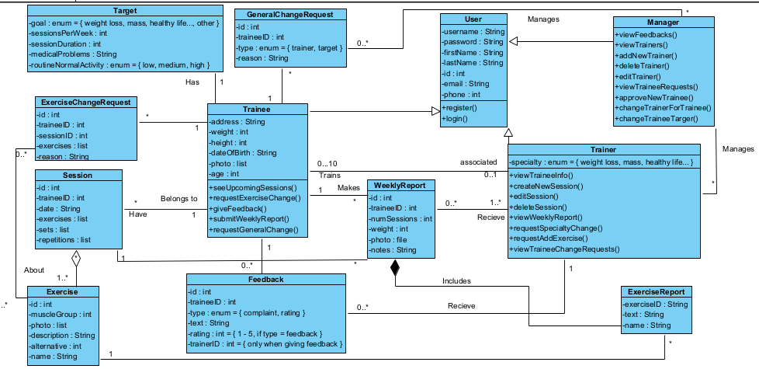

*Figure 3 – Class Diagram*

**4.2.4 Activity Diagram**

The Activity Diagram is a behavioral diagram intended to describe the dynamic aspects of the system. It is used to visualize important activities, or workflows in the system.

The first diagram displays the activity of Registration – starting from the user registering, and ending when the manager assigns a trainer to the client.

The second diagram displays the activity of a client requesting to change an exercise – starting from him making the request, and ending with the trainer changing it.

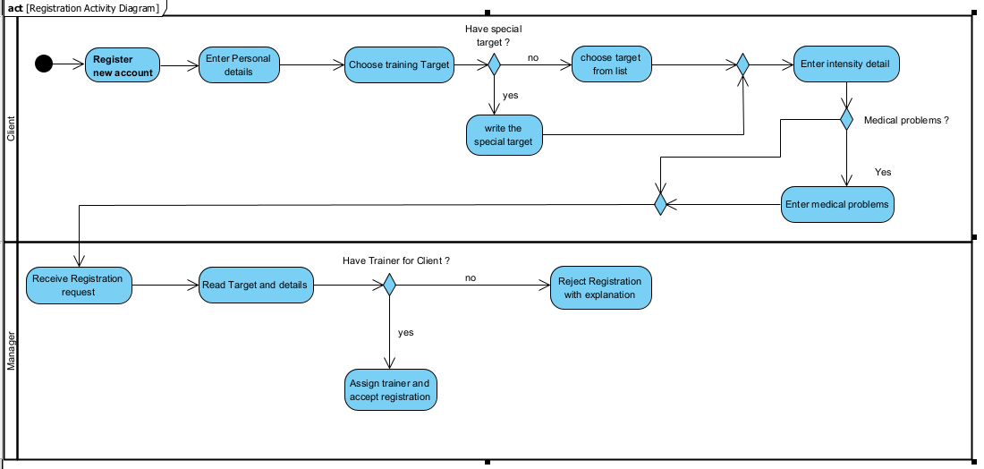

*Figure 4 – Activity Diagram (Registration)*

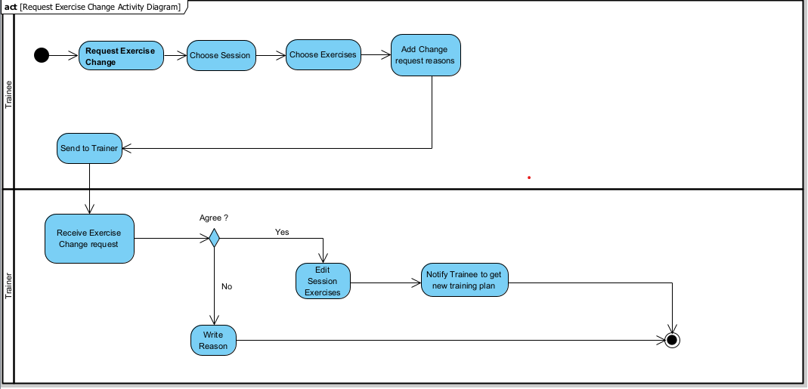

*Figure 5 – Activity Diagram (Request Exercise Change)*

**4.2.5 User Interface**

**Signup**

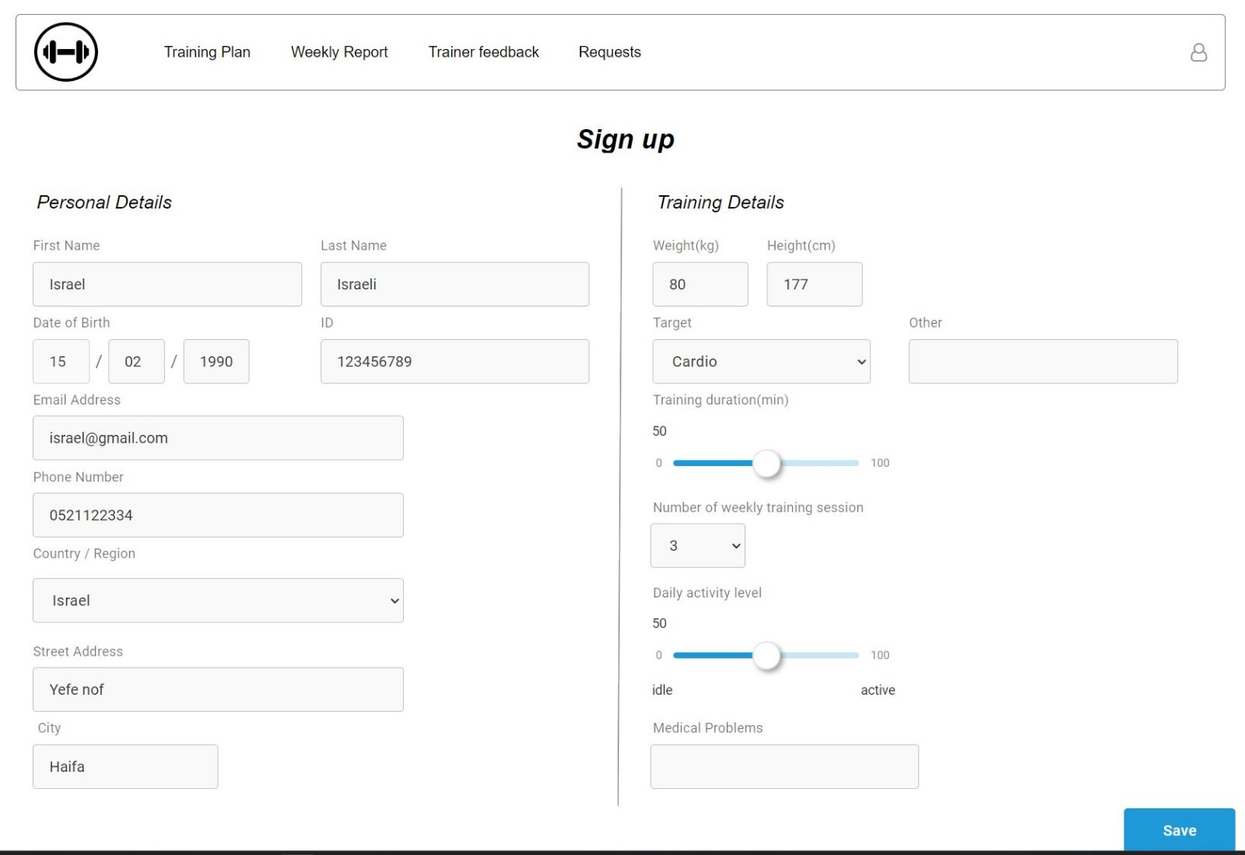

**Login**

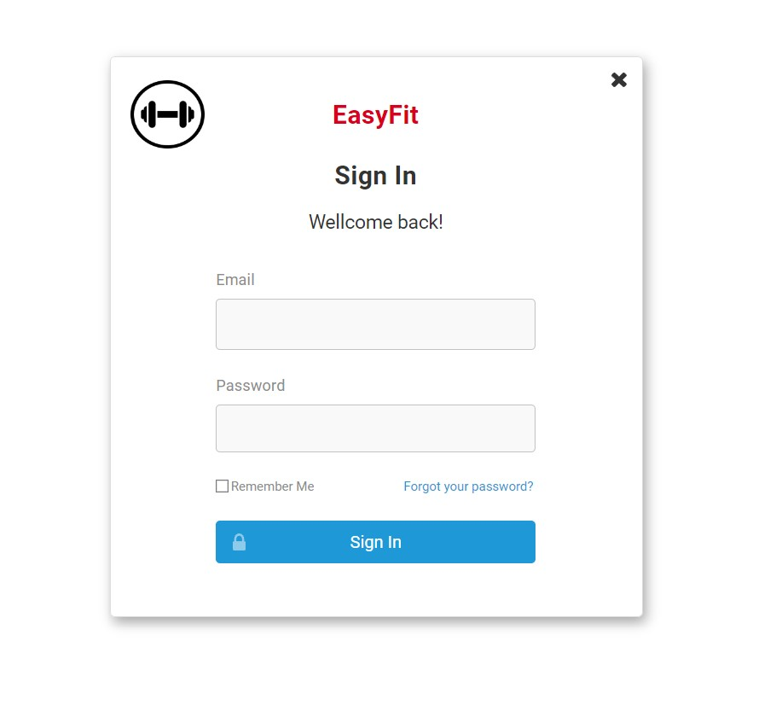

**Create Training**

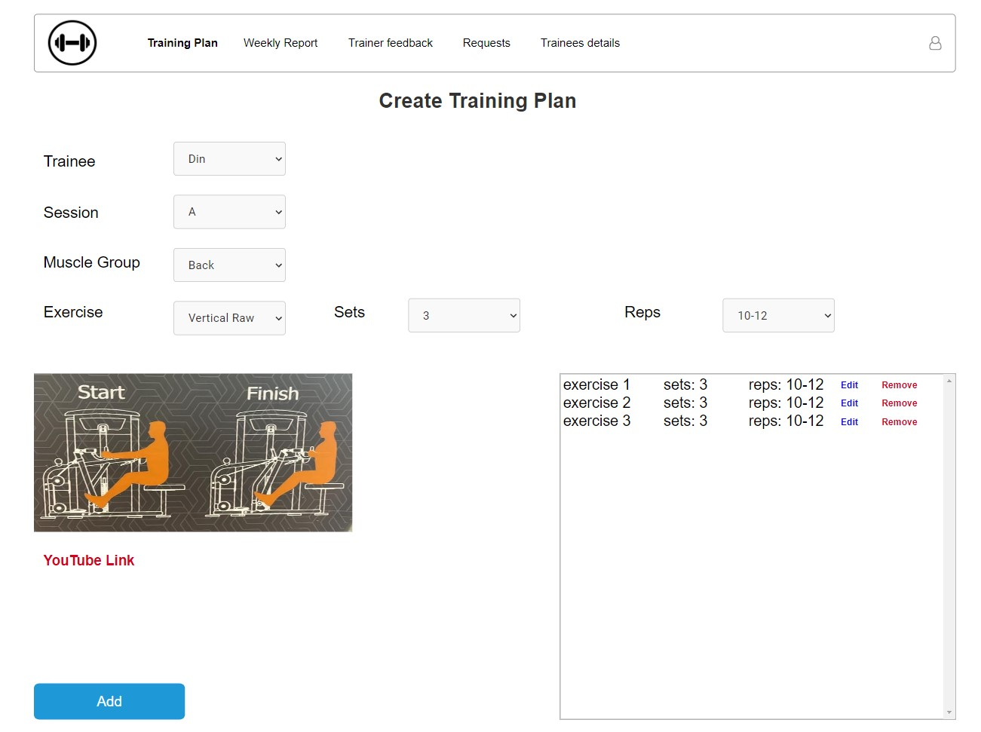

**View training**

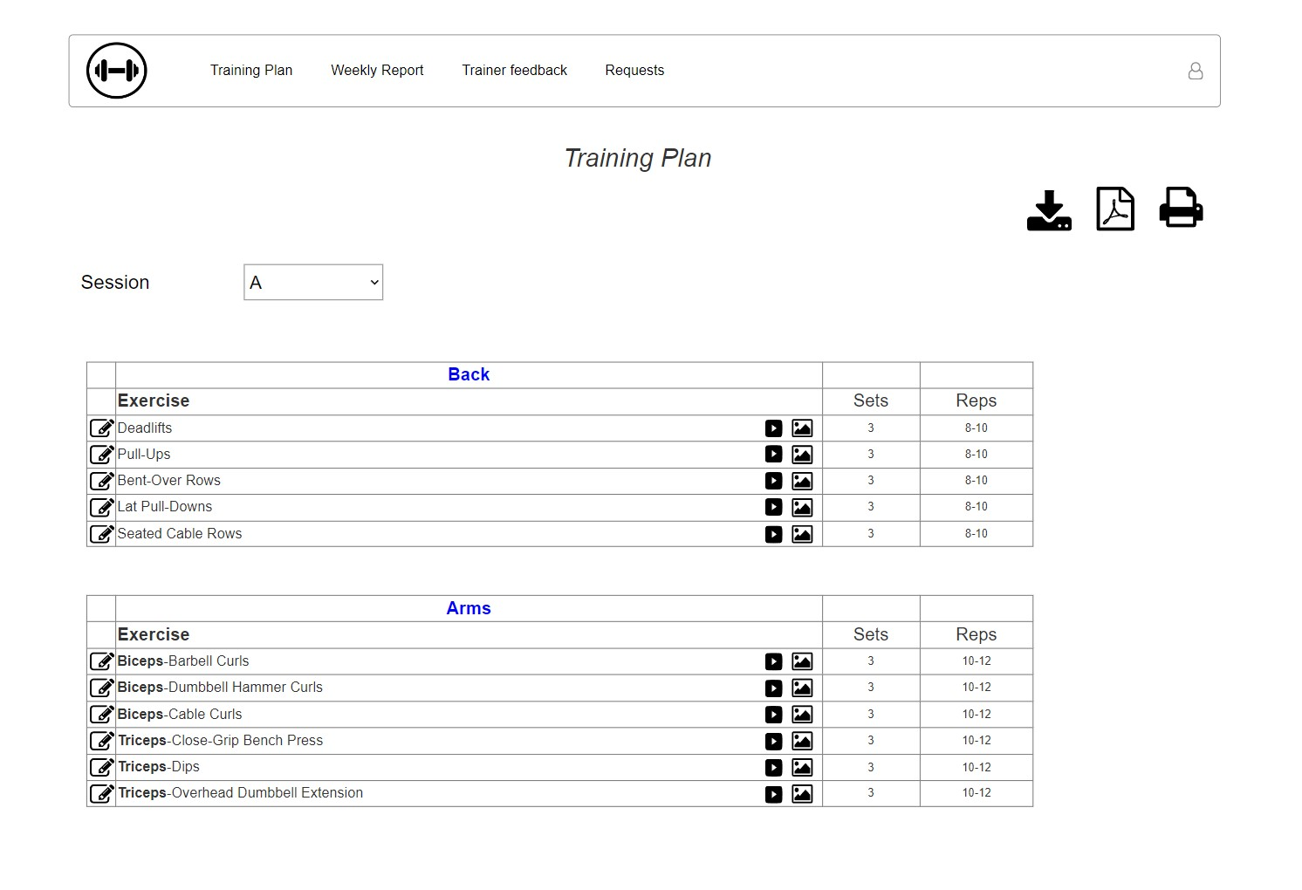

**Weekly report**

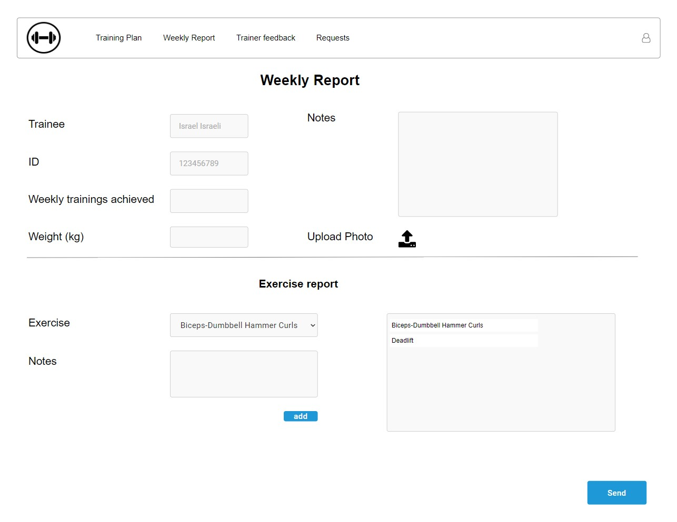

**Change trainer request**

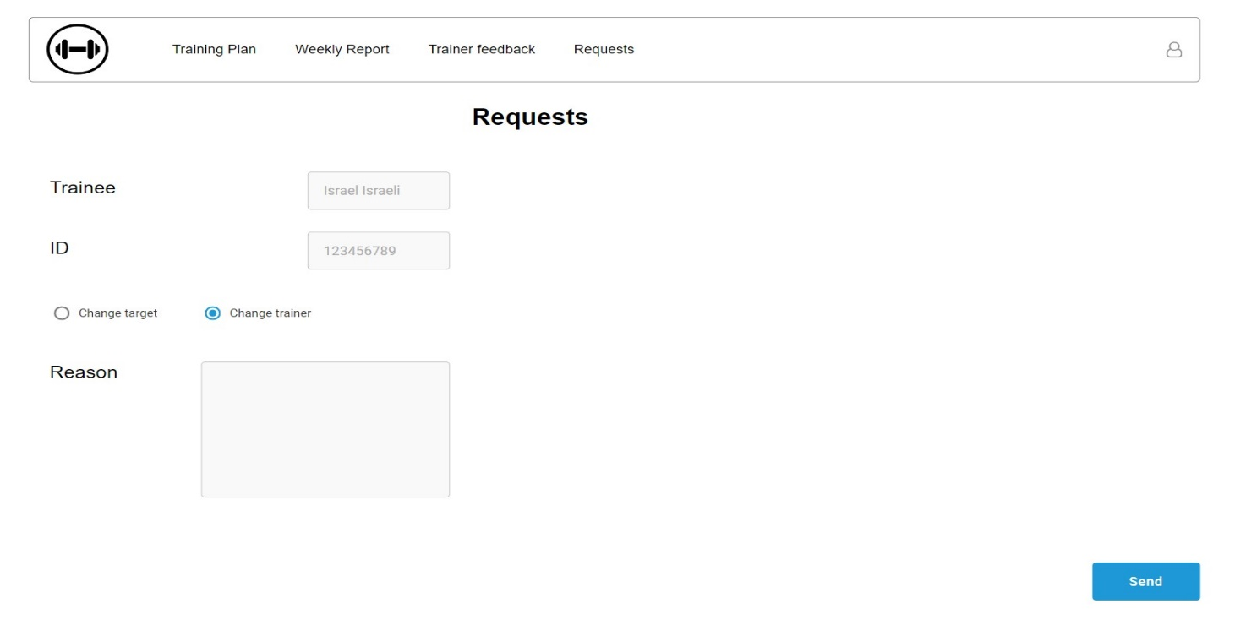

1. **Evaluation/Verification Plan**
   1. **System Requirements**

|  |  |
| --- | --- |
| ID | Requirement |
| 1 | The system allows clients to register |
| 2 | the system allows clients to specify training targets and personal restrictions (number of sessions per week) |
| 3 | The system allows Trainees to make weekly reports about the workouts |
| 4 | The system allows Trainees to request to change training targets, trainers and exercises |
| 5 | The system allows Trainees to give feedback/file complaint about trainers |
| 6 | The system allows Trainees to view upcoming sessions |
| 7 | The system allows trainers to create/edit/delete training sessions |
| 8 | The system allows trainers to view trainee’s profiles and information |
| 9 | The system allows trainers to view trainee’s weekly reports |
| 10 | The system allows trainers to manage trainee’s exercise change requests |
| 11 | The system allows managers to accept/reject client’s registration |
| 12 | The system allows managers to register new trainers/delete existing ones |
| 13 | The system allows managers to view trainer’s feedback and complaints |
| 14 | The system allows managers to assign clients different trainers |

**5.2 Testing Plan**

|  |  |  |  |
| --- | --- | --- | --- |
| Registration | | | |
| Description | Valid user Registration | | |
| # | Action | Inputs | Expected Result |
| 1 | Launch EasyFit |  | EasyFit main screen will appear |
| 2 | Click Register |  | Register screen appears |
| 3 | Enter Personal Details | Name, date of birth, id, email, phone, address, height, weight. | Data is checked and validated, all green V |
| 4 | Enter personal constraints (Target, # of sessions per week, level of intensity, medical problems) | Target from list or “other”, # of sessions per week, level of intensity, medical problems | Data is checked and validated, all green V |
| 5 | Click OK |  | Message saying registration waiting for approval |

|  |  |  |  |
| --- | --- | --- | --- |
| Login | | | |
| Description | Valid user Login | | |
| # | Action | Inputs | Expected Result |
| 1 | Launch EasyFit |  | EasyFit main screen will appear |
| 2 | Enter username and password | Username::test  password:test |  |
| 3 | Click Login |  | Data is checked and validated, main screen appears |

|  |  |  |  |
| --- | --- | --- | --- |
| Make weekly report | | | |
| Description | Send the trainer a weekly report of training | | |
| # | Action | Inputs | Expected Result |
| 1 | Click “Make weekly report” |  | Weekly report screen will appear |
| 2 | Enter details | # of sessions completed, weight, photo, any general problems or questions |  |
| 3 | Choose exercise from list | Exercise name |  |
| 4 | Fill exercise report for exercises client want | Difficulties, improvements, feedback regarding any exercise you want |  |
| 5 | Click “Report” |  | Message saying “Report sent to trainer” appears |

|  |  |  |  |
| --- | --- | --- | --- |
| Request change - exercises | | | |
| Description | Client requests to change one or more exercises in a session | | |
| # | Action | Inputs | Expected Result |
| 1 | Click “Requests” |  | Requests screen will appear |
| 2 | Click “Change Exercise” |  | Change exercise screen appears |
| 3 | Choose session |  | Session details screen appears |
| 4 | Choose exercise from list | exercise name |  |
| 5 | Click add |  | Exercise added to list of “toChange” |
| 6 | Enter reason for change request |  |  |
| 7 | Click “Send Request” |  | Message saying “Request sent to trainer” appears |

|  |  |  |  |
| --- | --- | --- | --- |
| Request change - General | | | |
| Description | Client requests to change trainer / training target | | |
| # | Action | Inputs | Expected Result |
| 1 | Click “Requests” |  | Requests screen will appear |
| 2 | Click “General Change” |  | General change screen appears |
| 3 | Choose type of change | Either change trainer or change training target |  |
| 4 | Enter reason for change request | Reason for change |  |
| 5 | Press “Send Request” |  | Message saying “Request sent to manager” appears |

|  |  |  |  |
| --- | --- | --- | --- |
| Give feedback | | | |
| Description | Client gives feedback about trainer | | |
| # | Action | Inputs | Expected Result |
| 1 | Click “Give Feedback” |  | Feedback screen will appear |
| 2 | Choose type from list | Enum: Feedback |  |
| 3 | Choose rating from list | 1-5 |  |
| 4 | Enter feedback text | text |  |
| 5 | Click “Send Feedback” |  | Message saying “Feedback sent to manager” appears |

|  |  |  |  |
| --- | --- | --- | --- |
| View upcoming sessions | | | |
| Description | Client views upcoming sessions of the week | | |
| # | Action | Inputs | Expected Result |
| 1 | Click “upcoming sessions” |  | “upcoming sessions” screen will appear |
| 2 | Choose specific session |  | “session Details” screen appears |

|  |  |  |  |
| --- | --- | --- | --- |
| Create training session | | | |
| Description | Trainer creates one session of the week for trainee | | |
| # | Action | Inputs | Expected Result |
| 1 | Click “Create Session” |  | “Create Session” screen will appear |
| 2 | Choose trainee from list | Trainee name |  |
| 3 | Choose session name | A/B/C |  |
| 4 | Choose muscle group and exercise from list | Arms, bicep curl | Exercise details appear on screen |
| 5 | Enter number of sets and reps | 3, 8 |  |
| 6 | Repeat 4-5 until finished |  |  |
| 7 | Click “Create Session” |  | Message saying “Session created” appears |

|  |  |  |  |
| --- | --- | --- | --- |
| Manage exercise change request | | | |
| Description | Trainer changes exercise following trainee request | | |
| # | Action | Inputs | Expected Result |
| 1 | Click “Requests” |  | Exercise change request screen will appear |
| 2 | Click request and view details |  | Request details shown |
| 3 | Choose exercise from list | Bicep curl |  |
| 4 | Choose alternative exercise | Different exercise |  |
| 5 | Repeat 3-4 until finished |  |  |
| 6 | Enter message text for trainee | “Changed as requested” |  |
| 7 | Click “Save Changes” |  | Message saying “Changes saved” appears |

|  |  |  |  |
| --- | --- | --- | --- |
| Accept client registration | | | |
| Description | Valid user Registration | | |
| # | Action | Inputs | Expected Result |
| 1 | Click “New client registration” |  | Registration requests screen will appear |
| 2 | Click request and view details |  | Client details and request window appear |
| 3 | Click “Accept registration” |  | “Assign trainer” window appears |
| 4 | Choose trainer from list | Trainer name |  |
| 5 | Click “Finish” |  | Message saying registration approved appears |

|  |  |  |  |
| --- | --- | --- | --- |
| Register new trainer | | | |
| Description | Valid user Registration | | |
| # | Action | Inputs | Expected Result |
| 1 | Click “New Trainer” |  | Add new trainer screen will appear |
| 2 | Fill trainer details | Din, Salman, 204404024, [dinsal1993@gmail.com](mailto:dinsal1993@gmail.com), 0545568449, Username, myPassword |  |
| 3 | Click “Add new trainer” |  | Message saying New trainer added appears |

|  |  |  |  |
| --- | --- | --- | --- |
| Assign new trainer for trainee | | | |
| Description | Valid user Registration | | |
| # | Action | Inputs | Expected Result |
| 1 | Click “Change requests” |  | General change request screen will appear |
| 2 | Choose type | trainer | Change trainer requests list appears |
| 3 | Click request and view details |  | Request details appears |
| 4 | Choose new trainer from list | Trainer name |  |
| 5 | Click “Save Changes” |  | Message saying “Trainer Changed” appears |

1. **References**
2. McClaran S. R. (2003). The effectiveness of personal training on changing attitudes towards physical activity. *Journal of sports science & medicine*, *2*(1), 10–14.
3. Zhou, M., Mintz, Y., Fukuoka, Y., Goldberg, K., Flowers, E., Kaminsky, P., Castillejo, A., & Aswani, A. (2018). Personalizing Mobile Fitness Apps using Reinforcement Learning. *CEUR workshop proceedings*, *2068*, <http://ceur-ws.org/Vol-2068/humanize7.pdf>.
4. Lena Busch, Till Utesch & Bernd Strauss (2022) Normalised step targets in fitness apps affect users’ autonomy need satisfaction, motivation and physical activity – a six-week RCT, International Journal of Sport and Exercise Psychology, 20:1, 223-244, DOI: [10.1080/1612197X.2020.1854820](https://doi.org/10.1080/1612197X.2020.1854820)
5. [11 Software Development Methodologies (Plus How To Pick One) | Indeed.com](https://www.indeed.com/career-advice/career-development/software-development-methodologies)
6. [dinsal1993/EasyFit: EasyFit - Capstone Project (github.com)](https://github.com/dinsal1993/EasyFit)